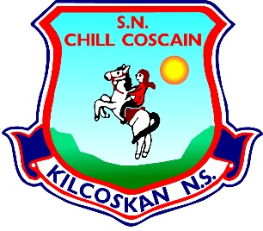
KILCOSKAN NATIONAL SCHOOL 2022-2023
Kilcoskan National School, Kilcoskan, The Ward, Co Dublin Ph: 01 8351508
www.kilcoskan.com

Sixth Class Booklist - Bookhaven Code: u1kt6c

Class books to be purchased by parents
Handwriting: Ready to Write H1 (Sixth Class)

Spelling: Spellbound 6 (Sixth Class) – CJ Fallon

English: 6th Class Starlight Combined Reader and Skills Book - (Folens)

Maths: Cracking Maths Pupil Book (Sixth Class) - Gill and MacMillan
New Wave Mental Maths (Sixth Class)
Maths Table Book

Gaeilge: Bua na Cainte pupil pack (Sixth Class)

SESE: Small World History (Sixth Class) *6th class for this year
Small World Geography & Science (Sixth Class) *6th class for this year

- Please ensure all books and stationery are clearly labelled for the first day of school.
- Please ensure ALL uniform items, tracksuits, coats, hats etc are clearly labelled.
- Please ensure all school bags, lunch boxes and beakers are clearly labelled.

