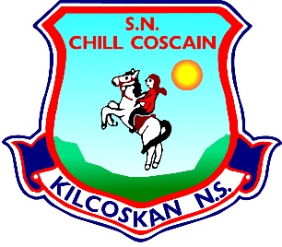
KILCOSKAN NATIONAL SCHOOL 2022-2023
Kilcoskan National School, Kilcoskan, The Ward, Co Dublin Ph: 01 8351508
www.kilcoskan.com

Fifth Class Booklist – Bookhaven Code: u1kt5c

Class books to be purchased by parents
Handwriting: Ready to Write G1 (Fifth Class)

Spelling: Spellbound 5 (Fifth Class) – CJ Fallon

English: Fifth Class Starlight Combined Reader & Skills Book (Folens)

Maths: Cracking Maths Pupil Book (Fifth Class) - Gill and MacMillan
New Wave Mental Maths (Fifth Class)
Maths Table Book

Gaeilge: Bua na Cainte pupil pack (Fifth Class) - Edco

SESE: Small World History (Sixth Class)
Small World Geography & Science (Sixth Class)

- Please ensure all books and stationery are clearly labelled for the first day of school.
- Please ensure ALL uniform items, tracksuits, coats, hats etc are clearly labelled.
- Please ensure all school bags, lunch boxes and beakers are clearly labelled.

