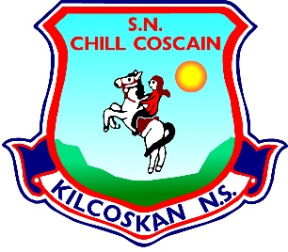
KILCOSKAN NATIONAL SCHOOL 2022 - 2023
Kilcoskan National School, Kilcoskan, The Ward, Co Dublin Ph: 01 8351508
www.kilcoskan.com

Second Class Booklist – Bookhaven Code: u1kt2c

Class books to be purchased by parents
English: Starlight Second Class Skills Book Code: 9781780909325

Handwriting: Ready to Write D1 Cursive (Second Class) Code: 9781845365158

Spelling: Spellbound 2 (Second Class) – CJ Fallon Code: 9780714416366

Maths: Cracking Maths Pupil’s Book (Second Class) - Gill and MacMillan
Code: 9780717154210
New Wave Mental Maths (Second Class) Code: 9781920962401
Maths Table Book – Code: 9780714410425

Gaeilge: Bua Na Cainte 2 (Second Class) Code: 9781845365332

SESE: Small World History, Geography & Science (Second Class)
Code: 9780714420837
* 2nd class to purchase Second class book

- Please ensure all books and stationery are clearly labelled for the first day of school.
- Please ensure ALL uniform items, tracksuits, coats, hats etc are clearly labelled.
- Please ensure all school bags, lunch boxes and beakers are clearly labelled.

