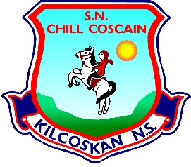
KILCOSKAN NATIONAL SCHOOL 2022/2023
Kilcoskan National School, Kilcoskan, The Ward, Co Dublin Ph: 01 8351508
www.kilcoskan.com

Senior Infants Booklist - Bookhaven Code: u1ktsi

Class books to be purchased by parents:

English: Starlight Skills Book – Senior Infants – Code: 9781780908151
Sight and Sound - *Junior Infant Book bought for Seniors

Handwriting: Edco Handwriting B – Mrs Murphy

Maths: Cracking Maths Set - Senior Infants – Code: 9780717154234

SESE: Small World – History, Geography & Science – Senior Infants Code: 9780714420806
*Senior Infants book to be bought this year for Senior Infants

Irish: Bua Na Cainte B – Senior Infants – Code: 9781845365875

- Please ensure all books and stationery are clearly labelled for the first day of school.
- Please ensure ALL uniform items, tracksuits, coats, hats etc are clearly labelled.
- Please ensure all school bags, lunch boxes and beakers are clearly labelled.

