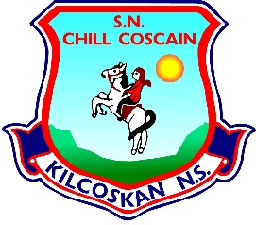
KILCOSKAN NATIONAL SCHOOL 2022 - 2023
Kilcoskan National School, Kilcoskan, The Ward, Co Dublin Ph: 01 8351508
www.kilcoskan.com

Junior Infants Booklist - Bookhaven Code: u1ktji

Class books to be purchased by parents:

English: Sight and Sound Book - Junior Infants - Code: 9781907330148
Starlight Pre-Reading Skills Book ********
Jolly Phonics – Phonics Book 1 – Junior Infants – Code: 9781844141678
Starlight Skills Book – Junior Infants – Code: 9781780907987

Handwriting: Edco Handwriting A – Mrs Murphy

Maths: Cracking Maths and Pupil Book - Junior Infants – Code: 9780717154227

SESE: Small World – History, Geography & Science – Senior Infants (Junior Infants will use Senior Infant book this year)

Irish: Bua Na Cainte A – Junior Infants – Code: 9781845365868

- Please ensure all books and stationery are clearly labelled for the first day of school.
- Please ensure ALL uniform items, tracksuits, coats, hats etc are clearly labelled.
- Please ensure all school bags, lunch boxes and beakers are clearly labelled.

