eServices Blurbs – Lexia & Coding Clubs

Lexia
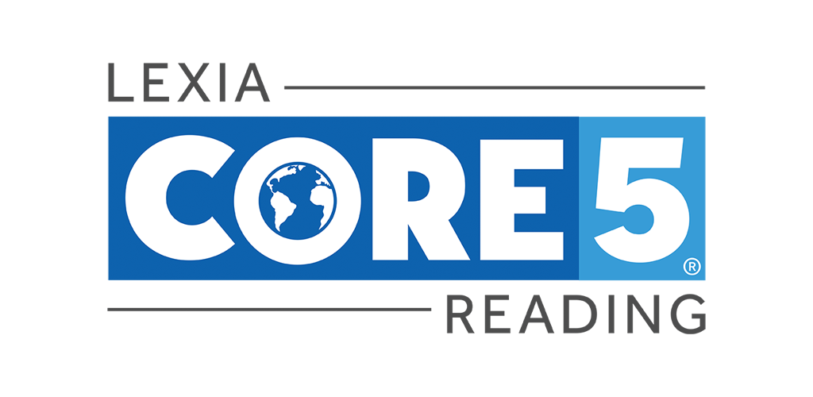
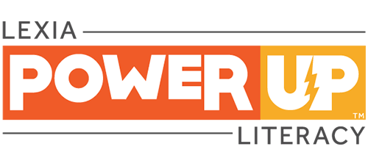
Lexia is an online program designed to help improve reading skills. With Lexia, users get to practice and develop the skills that make a successful reader. These include fluency, vocabulary and comprehension. The programs have been proven to accelerate progress and close the reading gap so that personalised learning can be achieved. Also, they are designed in a way which enables learners to use the program at school, in the library and at home.
There are two versions of Lexia available to our members: Lexia Core 5 is suitable for use by primary school pupils, and the Lexia Power Up literacy program is for secondary school students and adults.
Please email library.eservices@fingal.ie to sign up.

Coding Clubs
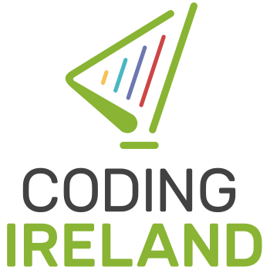

Through coding, children can become digitally literate in a new language; one that is becoming increasingly important. Coding fosters creativity and helps the learning process by allowing coders to learn through doing and experimentation.
Our online coding clubs with Coding Ireland will provide easily accessible tools for both parents and children who are interesting in learning to code.
There are 4 clubs open for membership, these are for ages:
6-7 years
8-10 years
11-13 years
14+
A parent or guardian may need to assist with those availing of the clubs for 6-7 years and 8-10 years, while the older children can work independently.
Please email library.eservices@fingal.ie to sign up.

