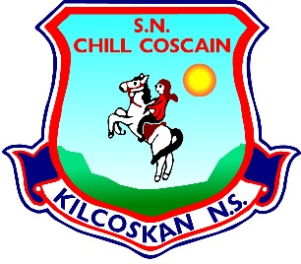
KILCOSKAN NATIONAL SCHOOL 2022-2023
Kilcoskan National School, Kilcoskan, The Ward, Co Dublin Ph: 01 8351508
www.kilcoskan.com

Fourth Class Booklist – Bookhaven Code: u1kt4c

Class books to be purchased by parents
Handwriting: Ready to Write F1 (Fourth Class)

Spelling: Spellbound 4 (Fourth Class) – CJ Fallon

English: 4th Class Starlight Combined Reader and Skills Book (Folens)

Maths: Cracking Maths Pupil Book (Fourth Class) - Gill and MacMillan
New Wave Mental Maths (Fourth Class)
Maths Table Book

Gaeilge: Bua na Cainte (Pack) (Fourth Class) - Edco

SESE: Small World History (Fourth Class) *4th Class book for this year
Small World Geography & Science (Fourth Class) *4th Class book for this year

- Please ensure all books and stationery are clearly labelled for the first day of school.
- Please ensure ALL uniform items, tracksuits, coats, hats etc are clearly labelled.
- Please ensure all school bags, lunch boxes and beakers are clearly labelled.

